TFT8001280-12-E
APPLICATION NOTE

This application note is only for reference and maybe changed without any notice .
Please contact TRULY R&D department for update files and product status before design for this product or release the order.

WRITTEN BY | APPROVED BY
Jiang Yongjie | Wang Weiqi

■ APPLICATION CIRCUIT

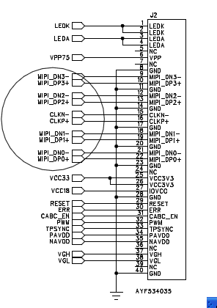

■ LCD POWER

VCC3V3=3.3V,IOVCC=1.8V

VGH=17V,VGL=-10V,PVDD=4.6V,NVDD=-4.75V

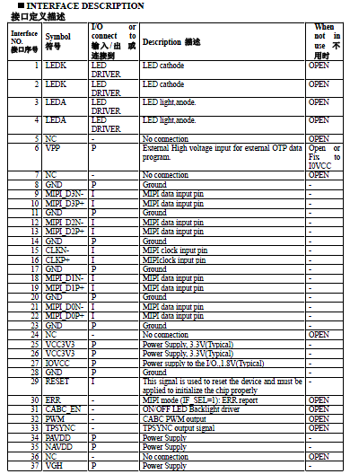
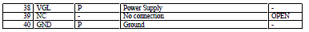

Power ON/OFF Sequence

Power on sequence
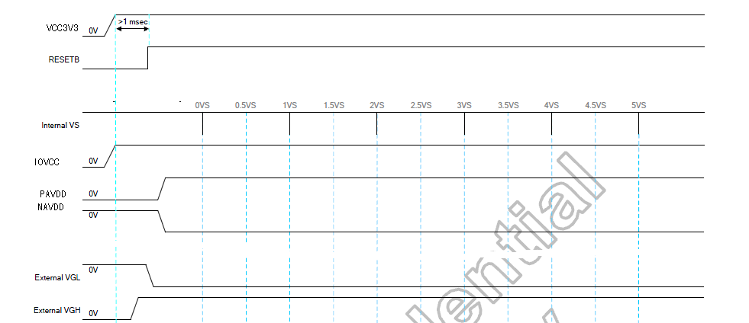

Power off sequence

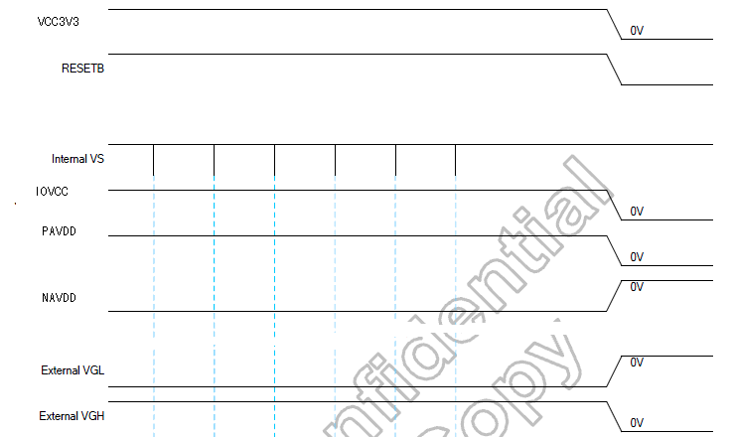
■ Reset Timming

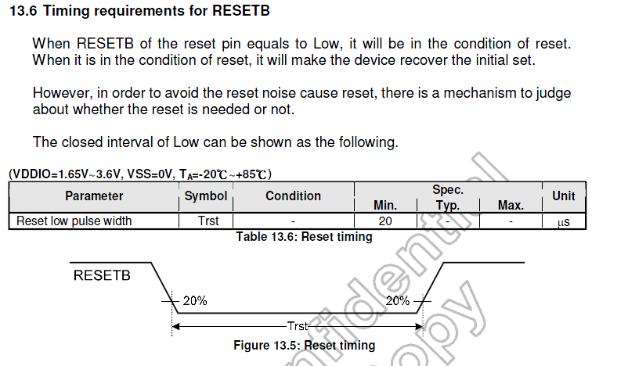

■ INITIAL CODE

#if 1

TC358768_DCS_write_1A_1P(0xB0,0x00);
TC358768_DCS_write_1A_1P(0xB1,0x67);
TC358768_DCS_write_1A_1P(0xB3,0x48);
TC358768_DCS_write_1A_1P(0xBB,0xE8);
TC358768_DCS_write_1A_1P(0xC4,0x09);
TC358768_DCS_write_1A_1P(0xC6,0x09);
TC358768_DCS_write_1A_1P(0xCB,0x3F);
TC358768_DCS_write_1A_1P(0xCC,0x2D);
TC358768_DCS_write_1A_1P(0xCD,0x20);
TC358768_DCS_write_1A_1P(0xCE,0x1D);
TC358768_DCS_write_1A_1P(0xCF,0x0A);
TC358768_DCS_write_1A_1P(0xD0,0x00);
TC358768_DCS_write_1A_1P(0xD1,0x02);
TC358768_DCS_write_1A_1P(0xD2,0x0D);
TC358768_DCS_write_1A_1P(0xD3,0x10);
TC358768_DCS_write_1A_1P(0xD4,0x10);
TC358768_DCS_write_1A_1P(0xD5,0x0E);
TC358768_DCS_write_1A_1P(0xD6,0x3F);
TC358768_DCS_write_1A_1P(0xD7,0x2D);
TC358768_DCS_write_1A_1P(0xD8,0x20);
TC358768_DCS_write_1A_1P(0xD9,0x1D);
TC358768_DCS_write_1A_1P(0xDA,0x0A);
TC358768_DCS_write_1A_1P(0xDB,0x00);
TC358768_DCS_write_1A_1P(0xDC,0x01);
TC358768_DCS_write_1A_1P(0xDD,0x0E);
TC358768_DCS_write_1A_1P(0xDE,0x10);
TC358768_DCS_write_1A_1P(0xDF,0x10);

TC358768_DCS_write_1A_1P(0xE0,0x0E);
TC358768_DCS_write_1A_1P(0xB0,0x02);
TC358768_DCS_write_1A_1P(0xB1,0x00);
TC358768_DCS_write_1A_1P(0xB2,0x00);
TC358768_DCS_write_1A_1P(0xB3,0x10);
TC358768_DCS_write_1A_1P(0xB4,0x0E);
TC358768_DCS_write_1A_1P(0xB5,0x0C);
TC358768_DCS_write_1A_1P(0xB6,0x0C);
TC358768_DCS_write_1A_1P(0xB7,0x0A);
TC358768_DCS_write_1A_1P(0xB8,0x0A);
TC358768_DCS_write_1A_1P(0xB9,0x08);
TC358768_DCS_write_1A_1P(0xBA,0x00);
TC358768_DCS_write_1A_1P(0xBB,0x00);
TC358768_DCS_write_1A_1P(0xBC,0x00);
TC358768_DCS_write_1A_1P(0xBD,0x00);
TC358768_DCS_write_1A_1P(0xBE,0x00);
TC358768_DCS_write_1A_1P(0xBF,0x00);

TC358768_DCS_write_1A_1P(0xC0,0x08);
TC358768_DCS_write_1A_1P(0xC1,0x06);
TC358768_DCS_write_1A_1P(0xC2,0x06);
TC358768_DCS_write_1A_1P(0xC3,0x02);
TC358768_DCS_write_1A_1P(0xC4,0x04);
TC358768_DCS_write_1A_1P(0xC5,0x00);
TC358768_DCS_write_1A_1P(0xC6,0x00);
TC358768_DCS_write_1A_1P(0xC7,0x00);
TC358768_DCS_write_1A_1P(0xC8,0x00);
TC358768_DCS_write_1A_1P(0xC9,0x0F);
TC358768_DCS_write_1A_1P(0xCA,0x0D);
TC358768_DCS_write_1A_1P(0xCB,0x0B);
TC358768_DCS_write_1A_1P(0xCC,0x0B);
TC358768_DCS_write_1A_1P(0xCD,0x09);
TC358768_DCS_write_1A_1P(0xCE,0x09);
TC358768_DCS_write_1A_1P(0xCF,0x07);

TC358768_DCS_write_1A_1P(0xD0,0x00);
TC358768_DCS_write_1A_1P(0xD1,0x00);
TC358768_DCS_write_1A_1P(0xD2,0x00);
TC358768_DCS_write_1A_1P(0xD3,0x00);
TC358768_DCS_write_1A_1P(0xD4,0x00);
TC358768_DCS_write_1A_1P(0xD5,0x00);
TC358768_DCS_write_1A_1P(0xD6,0x07);
TC358768_DCS_write_1A_1P(0xD7,0x05);
TC358768_DCS_write_1A_1P(0xD8,0x05);
TC358768_DCS_write_1A_1P(0xD9,0x01);
TC358768_DCS_write_1A_1P(0xDA,0x03);
TC358768_DCS_write_1A_1P(0xDB,0x00);
TC358768_DCS_write_1A_1P(0xDC,0x00);

TC358768_DCS_write_1A_1P(0xB0,0x03);
TC358768_DCS_write_1A_1P(0xC4,0x07);
TC358768_DCS_write_1A_1P(0xC6,0x05);
TC358768_DCS_write_1A_1P(0xC7,0x01);
TC358768_DCS_write_1A_1P(0xD0,0x00);
TC358768_DCS_write_1A_1P(0xD1,0x04);
TC358768_DCS_write_1A_1P(0xD2,0x04);
TC358768_DCS_write_1A_1P(0xD3,0x01);
TC358768_DCS_write_1A_1P(0xD4,0x02);
TC358768_DCS_write_1A_1P(0xD5,0x03);
TC358768_DCS_write_1A_1P(0xD6,0x04);

TC358768_DCS_write_1A_0P(0x11);
TC358768_DCS_write_1A_0P(0x29);

WaitTime(200);
#endif

